The Minyawi Project…
The seeds of The Minyawi Project (T.M.P.) were sown around 2006 whilst on tour playing for the inimitable Natacha Atlas. After a sell out concert in Belgium, Aly el Minyawi and Dr. Eser Ebcin decide to stage an impromptu concert in the lobby of the hotel in which they were staying. After receiving rapturous plaudits from the late night revellers they retired to their rooms. On waking up and meeting in the breakfast room, the decision was made to start work immediately on the first album The Minyawi Project. Working in collaboration with some of the worlds greatest ethnic music session players, they put together an album which boasts an eclectic mix of east west north and south.
The Players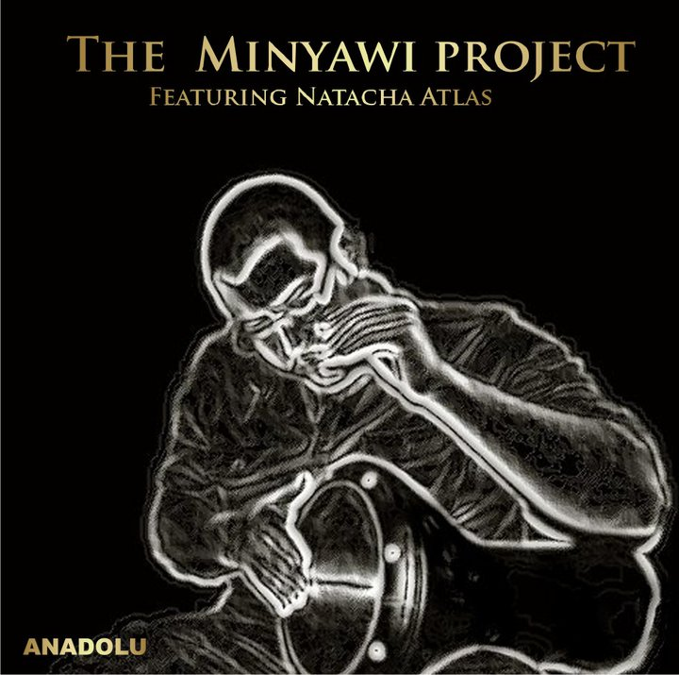
Aly el Minyawi:
From the tender age of two he picked up his first ever drum and has been wowing crowds ever since.
He started his career by playing with his father, the Grand Master. Well what better way to learn what it means to play music then to watch the best! Aly el Minyawi has played his craft at weddings, at restaurants, at festivals, at all types of formal and informal gathering. The one thing you notice is that he consistently plays with his full heart and passion regardless to the gathering or occasion. This is the action of a true artist.
Aly was born the child of the Grand Master of drummer Ibrahim el Minyawi. Having listened and learnt from the best in the industry he managed to do something incredible, he learnt and yet created style of his own. He has managed to craft his own individual style of music and managed to bring a contemporary zeal to his music and rhythm whilst keeping loyal to his Egyptian roots.
It is this wonderful and all inspiring passion and ability for his music that has allowed him to travel the world and play with such artists as Coldplay, Natacha Atlas and many, many more artists from around the globe.
Eser Ebcin:
Student of life, Eser Ebcin has dedicated every moment of his life to musical furtherment. Starting from his background as a percussionist he quickly moved to the keyboards with guidance and tutorage from his mentor, the late great clarinettist Cetin Bukey. He has spent a number of years touring the world with various bands finding inspiration and ideas along the way. Today he owns a recording studio in North London, which he operates with his business partner Anil Gocen. The Studio, U-71, has swiftly become a hub for international talent and is currently expanding it’s operations by opening a second branch in Istanbul.
Anil Gocen:
Of Rom origin, this multi talented musician was born in London to a family already steeped in musical history. Anil was educated in film music composition and is a business partner of Eser Ebcin at U-71 Studios. Anil plays the Keyboards and Violin, has performed worldwide with varying artists. He has carved himself a niche in the market by being so adaptive to both eastern and western music genres.
Ozkan Gezen:
Ozkan hails from Afyon, a city in the western region of Turkey. Growing up in an ultra competitive environment, the advancement of musical knowledge was not just for personal betterment but also to sustain a family. Surrounded by many highly talented musicians, it was imperative to have an upper hand.
Thus, Ozkan became a multi instrumentalist to a degree that surpasses anyone in that region or perhaps the whole of Turkey. He must be heard to be appreciated!
Ercument Ibrahim:
It was once said of the Violinist Niccolo Paganini “he plays the instrument in such a manner that it sounds like the human voice”. Ercument Ibrahim is a Violinist who adds aural dimensions to the violin not heard since the times of the great Signor Paganini. The soulful deliverance of his inimitable technique will surely sway your soul from east to west. Watch as his bow makes his violin sing ethereal melodies. Ercument also comes from a long line of highly talented musicians; he currently lives and works in London.
Ismail Eren:
Ismail plays the baglama, the most commonly used string folk instrument in Turkey, the baglama has seven strings divided into courses of two, two and three.
Ismail moved to London in 2003 after deciding to expand his musical knowledge and career. He originally comes from Antep in Turkey, a region well known for it’s folk music. He has been a keen player for over 20 years and has amassed a large student following in London. He is a master of Selpe and Pence techniques and has his roots based within Alevi teachings. His music abilities have now been officially recognised after he became the first ever musician to perform live in the House of Commons. He is currently teaching Baglama technique to interested students in the UK.
Mahmut Emrah Tak:
Mahmut was born in 1981 in Bursa, western Turkey. His talent became clear early on in his life when he became the country’s highest achieving student at the Bursa State Conservatory for musical excellence.
Although he was studying classical Turkish art muzik and playing the Oud, he found an interest in Acoustic guitars, most notably Flamenco style. Adding his already vast knowledge of Turkish music to the Flamenco repertoire, he has succeeded in creating a unique style of guitar playing. He can now be found performing with the world’s most prominent musicians in this genre. Mahmut Emrah Tak is a true musical genius and continues to expand his knowledge whilst delighting his audience.

